SET UP EFK ON EC2

Efk
Efk stands for Elasticsearch Fluentd and kibana. Efk is a popular and the best open-source choice for the kubernetes logs aggregation and analysis. Elasticsearch is a distributed and scalable search engine commonly used to sift through large volumes of log data.
Ec2

- Ec2 stands for Amazon elastic compute cloud
- Amazon ec2 is a web service that provides resizable compute capacity in the cloud
- To run the application security group zones. user data applications installation it's nothing but remote server
- You can scale the computer capacity up and down as per computer requirement changes

Launch ec2 instances-1 and choose: Ubuntu For Elasticsearch & Kibana

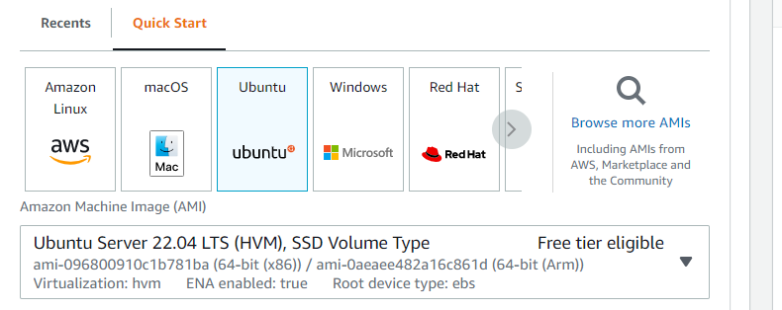

Choose instance type which is equals to 8CPU(Prerequisite)

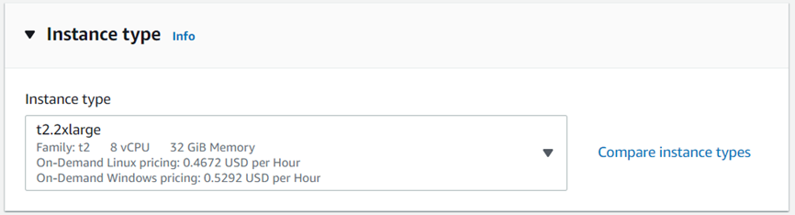

·
Set Security group inbound rules as below and attach to ec2
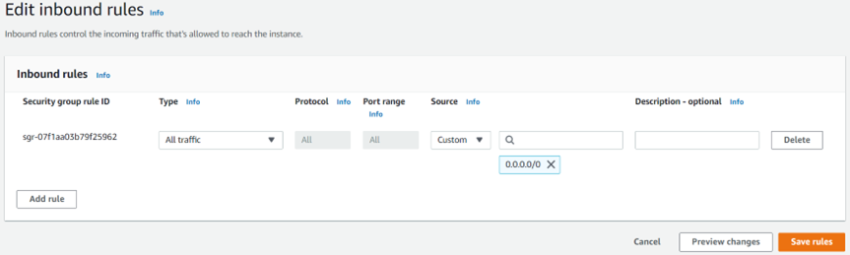

· Login to ec2 instance-1 in Git Bash : ssh -i pem ubuntu@18.143.159.72
· Run following commands as ubuntu user
Installing Elasticsearch and Kibana on ec2 instance-1:
1. wget -qO - https://artifacts.elastic.co/GPG-KEY-elasticsearch | sudo apt-key add -

2. sudo apt-get install apt-transport-https
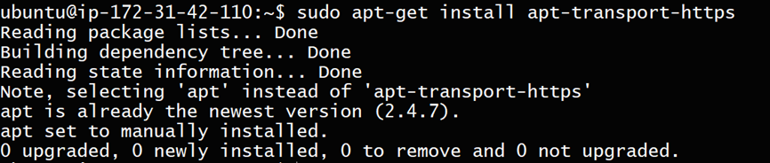
3. echo "deb https://artifacts.elastic.co/packages/7.x/apt stable main" | sudo tee /etc/apt/sources.list.d/elastic-7.x.list
4. sudo apt-get update
5. sudo apt-get install elasticsearch


6. sudo vim /etc/elasticsearch/jvm.options
Before
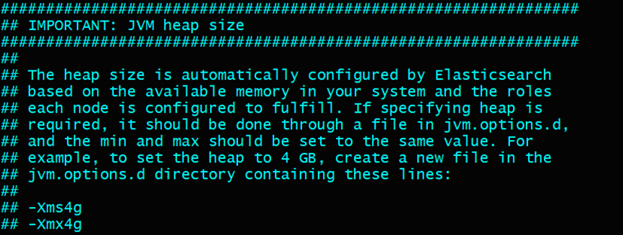
After
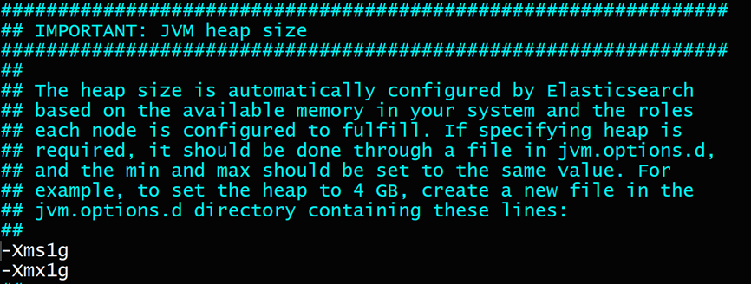
7. sudo systemctl start elasticsearch.service
8. sudo systemctl enable elasticsearch.service
9. sudo systemctl status elasticsearch.service
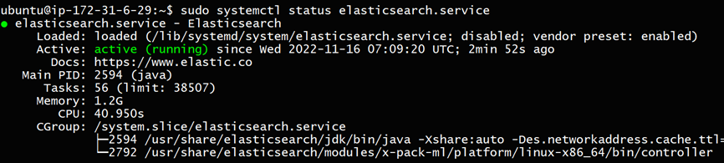
curl 127.0.0.1:9200
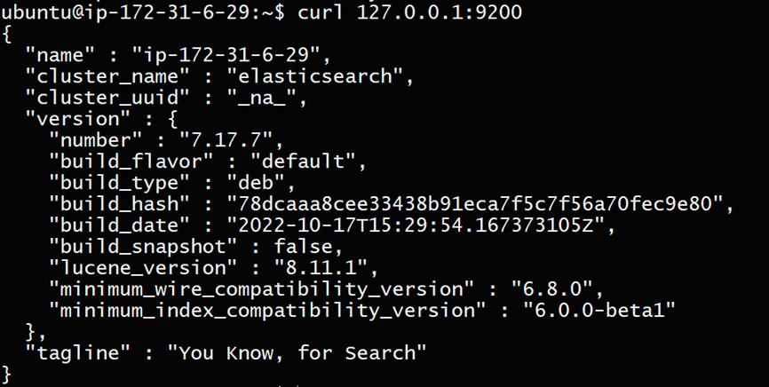

Elastic search installation is completed successfully and running
1. sudo apt-get install kibana
sudo vi /etc/kibana/kibana.yml
set => server.host: 0.0.0.0
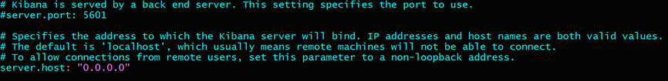

1. sudo systemctl start kibana.service
2. sudo systemctl enable kibana.service
sudo systemctl status kibana.service

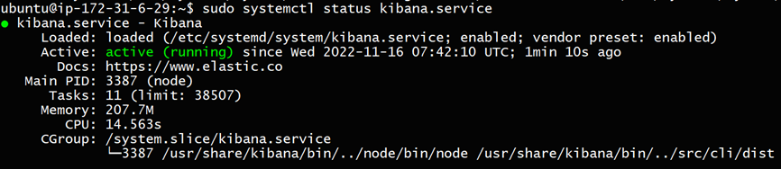

Instance public IP:5601
Result in Web

 Kibana installation is completed successfully and running

change elasticsearch configuration
sudo vi /etc/elasticsearch/elasticsearch.yml
set => network.host: 0.0.0.0
set => discovery.seed_hosts: ["127.0.0.1"]

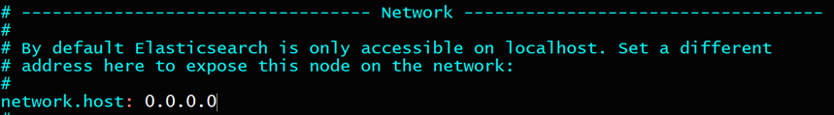

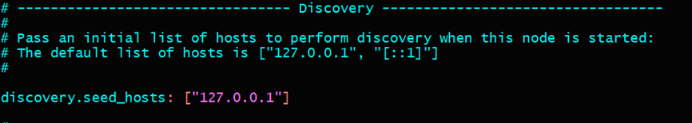

1. sudo systemctl restart elasticsearch.service
ec2 Instance-1 public IP:9200

Result in Web

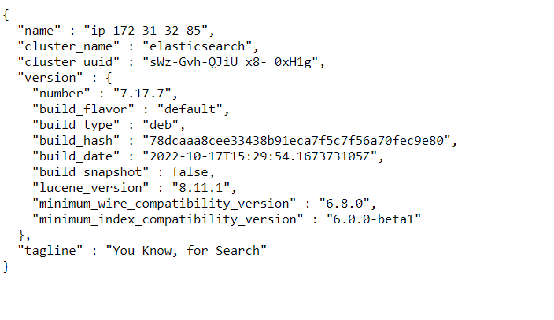

Launch ec2 instance-2 and choose: Ubuntu (For Filebeat & Web server)

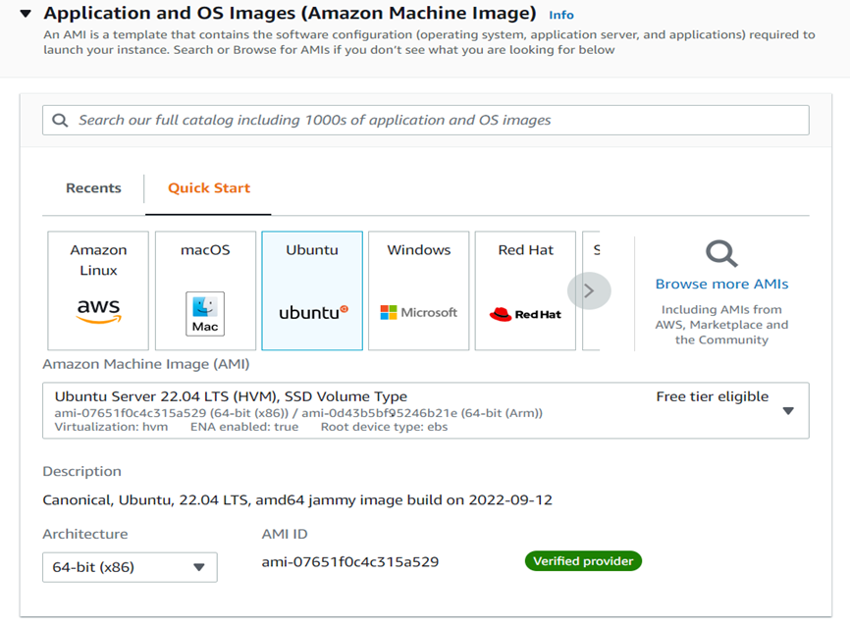

· Set Security group inbound rules as below and attach to ec2

· Login to ec2 instance-2 in Git Bash : ssh -i pem ubuntu@18.140.159.77
· Run following commands as ubuntu user
Installing Filebeat on Ec2 instance-2:
wget -qO - https://artifacts.elastic.co/GPG-KEY-elasticsearch | sudo apt-key add -

sudo apt-get install apt-transport-https

1. echo "deb https://artifacts.elastic.co/packages/7.x/apt stable main" | sudo tee /etc/apt/sources.list.d/elastic-7.x.list
2. sudo apt-get update
3. sudo apt-get install filebeat
sudo vi /etc/filebeat/filebeat.yml
set => outputs hosts: ["172.31.84.154:9200"] (ec2 instance-1 private IP:9200)

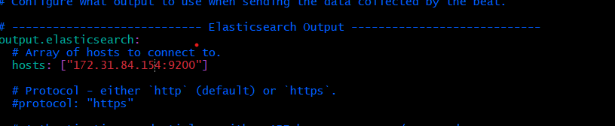

1. sudo systemctl start filebeat.service
2. sudo systemctl enable filebeat.service

sudo systemctl status filebeat.service

Filebeat installation is completed successfully and running
Installing tomcat on Ec2 instance-2:
1. sudo su -
run following commands as root user
2. cd /opt
3. apt install openjdk-11-jdk
wget https://dlcdn.apache.org/tomcat/tomcat-10/v10.0.27/bin/apache-tomcat-10.0.27.tar.gz

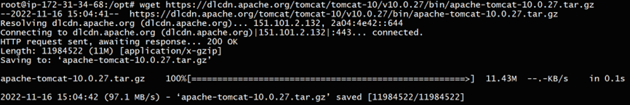

1. tar -zvxf apache-tomcat-10.0.27.tar.gz
2. cd apache-tomcat-10.0.27/bin/
ls -ltr

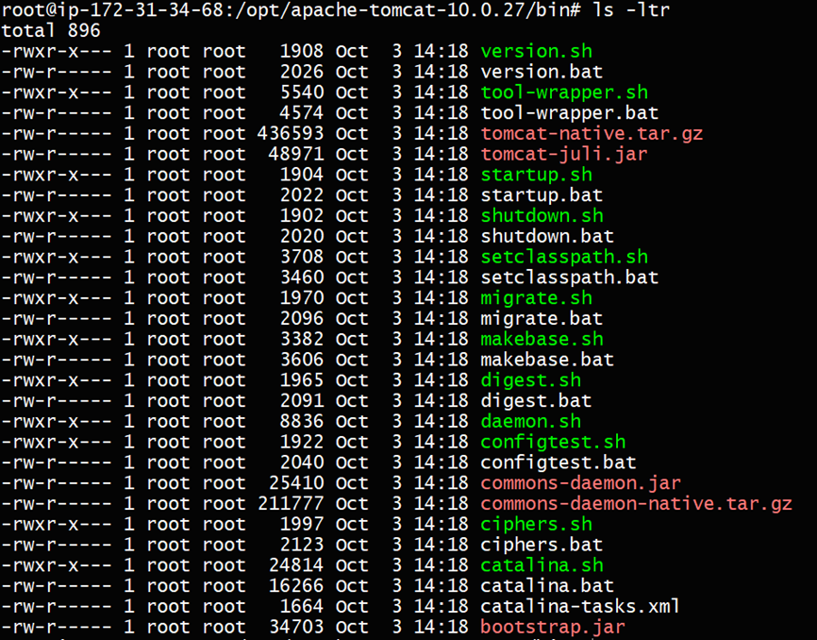

./startup.sh

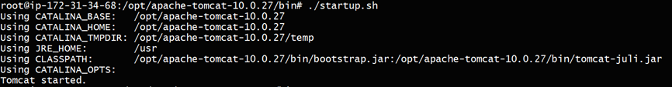

ps -ef | grep "tomcat"

create logs by accessing to Ec2 instance-2 public IP:8080

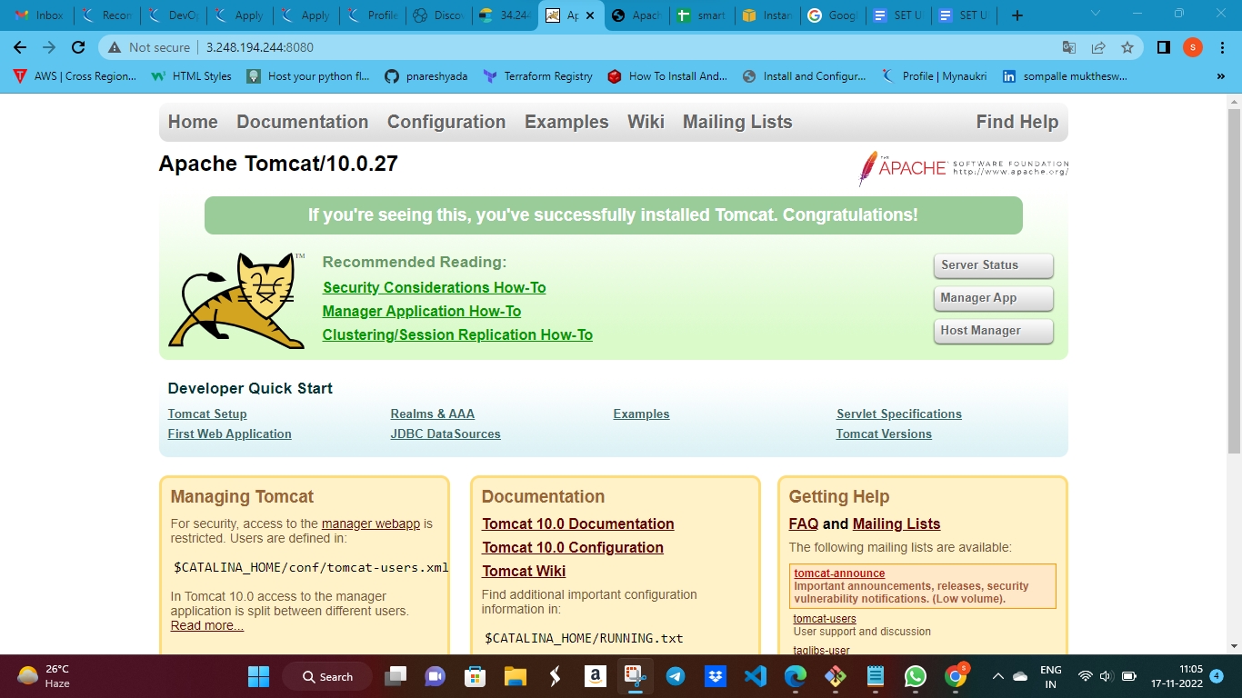

1. check logs in /opt/apache-tomcat-10.0.27/logs/*.log

Tomcat installation is completed successfully and running

change Filebeat configuration
sudo vi /etc/filebeat/filebeat.yml
set => enabled: true
set => - /opt/apache-tomcat-10.0.27/logs/*log*

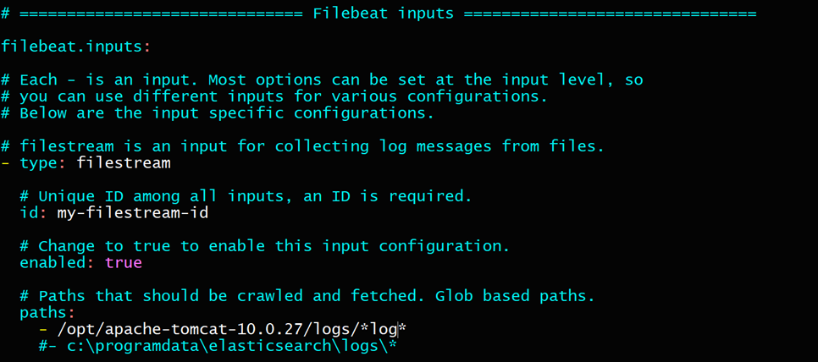

1. sudo systemctl restart filebeat.service

Log in to Kibana dashboard with ec2 instance-1 public IP:5601
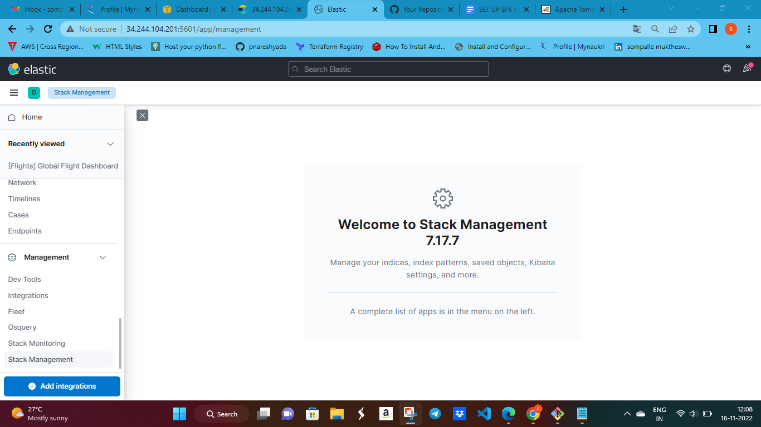

· open Stack Management > Index Management ,check for filebeat logs file availability

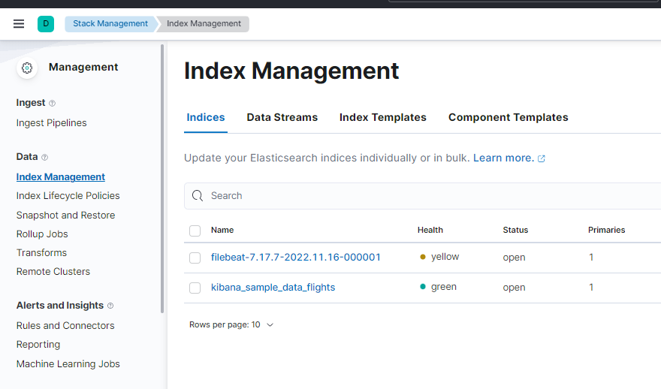

· create Index Pattern

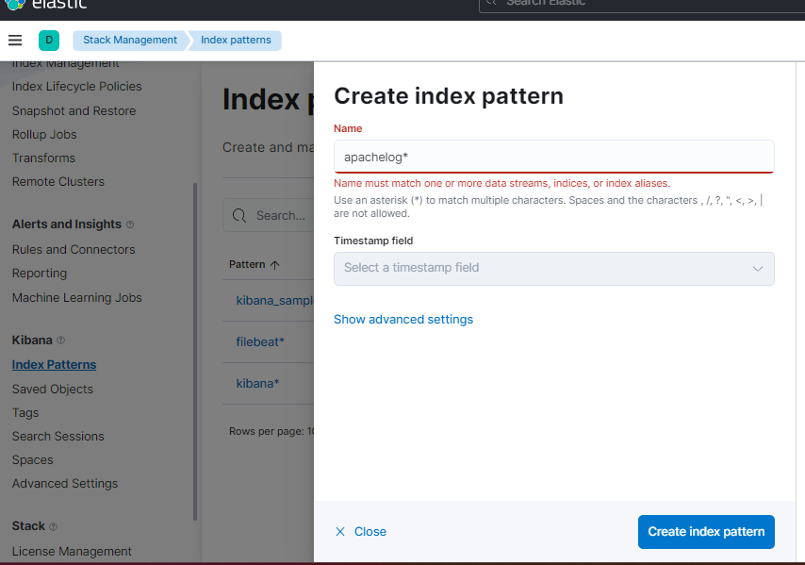

· open Discover
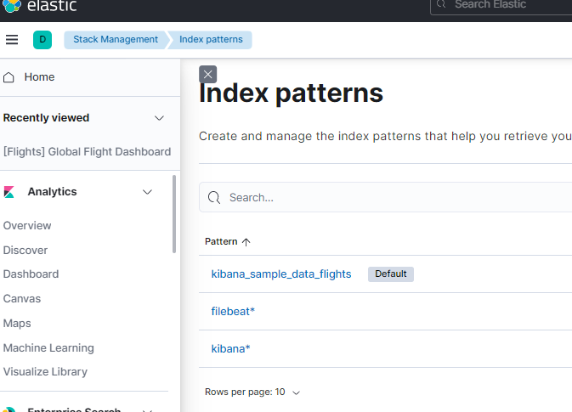

· Choose the created index pattern and time to display logs

